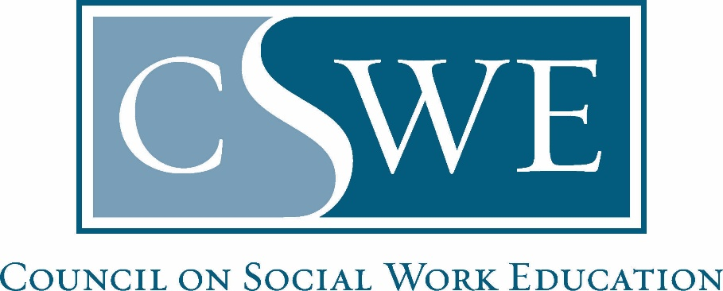
Board of Accreditation (BOA)
Department of Social Work Accreditation (DOSWA)

Post-Master’s Fellowship Accreditation
Cohort Report

Directions

Purpose
- Cohort Reports are completed by accredited post-master’s social work fellowship programs to obtain information on the recent cohort and program assessment activities.
- The report also includes verification of the program’s continued compliance with the Post-Master’s Social Work Fellowship Accreditation Standards, approved and adopted in October 2021.

Formatting & Submission
- Submit this completed report as a Microsoft Word document or searchable PDF, per section 9. Document Submission Guidelines in the Fellowship Accreditation Handbook.
  - The application must be a single document and may not include separate attachments nor appendices.
  - Scanned documents will not be accepted.
- Email the completed application to fellowshipaccred@cswe.org.
- Cohort reports are due within 60 days of each cohort’s completion date.

Timeframe for Review & Response
Cohort Reports are reviewed and processed within 30-days of receipt. CSWE accreditation staff may request clarifying information. Upon acceptance, programs will receive an email confirmation.

Questions concerning the Cohort Report or maintaining accreditation may be directed to the Manager of Social Work Fellowship Accreditation at fellowshipaccred@cswe.org or (703) 519-2062.

Table of Contents
Directions 1
Fellowship Program Information 3
Cohort Information 3
Recent Cohort: 3
Recent Program Assessment Efforts: 4
Next Cohort: 4
Program Changes Reporting Verification 4
Changes that Require Notification to CSWE: 5
Changes to Program Options: 5
Attestations 6
Cohort Report Authorization 7

Fellowship Program Information
Name of Fellowship Program:

Program Mailing Address:

Fellowship Program Director Information | Name, Credentials  Title  E-mail  Phone
Department Administrator Information  (Person to whom the program director reports) | Name, Credentials  Title  E-mail  Phone
Comprehensive Review of Program’s Listing on Directory of Accredited Fellowship Programs  (check one) | ☐ Listing is correct  ☐ Updates are needed as follows:

Cohort Information

Recent Cohort:
- Identify when this cohort started the fellowship.
Click or tap to enter a date.

- Identify when this cohort completed the fellowship.
Click or tap to enter a date.

- Identify the total number of trainees that were enrolled in this cohort.
Click here to insert number.

- Identify the number of trainees in this cohort that successfully completed the program.
Click here to insert number.

If any trainees did not successfully complete the program, identify reason(s) here: Click here to enter text.

Recent Program Assessment Efforts:

- Briefly describe how the program assessed achievement of the program’s mission and goals in the past year (Accreditation Standard 4.1):
Click here to enter text.

- Briefly describe how the program has assessed curriculum effectiveness in the past year (Accreditation Standard 4.2):
Click here to enter text.

- Briefly describe how the program has assessed the effectiveness of the program’s learning environment for the recent, or previous, cohort (Accreditation Standard 4.3).
Click here to enter text.

- Briefly describe how the program has used program completion and post-completion preparedness of fellows to assess the effectiveness of the program over the past year (Accreditation Standard 4.4)
Click here to enter text.

- In accordance with Accreditation Standard 4, with a commitment to ongoing continuous program improvement, briefly describe any changes made to the program as a result of these assessment efforts.
Click here to enter text.

Next Cohort:

- In accordance with Accreditation Standard 3.1, with a commitment to anti-racism, diversity, equity and inclusion, describe how the program actively encouraged underrepresented groups to apply to the program:
Click here to enter text.

- Identify when the next cohort started or is expected to start.
Click or tap to enter a date.

- Identify when the next cohort is expected to complete the program.
Please note: The next Cohort Report will be due within 60 days of that cohort completing the program.
Click or tap to enter a date.

Program Changes Reporting Verification

Changes that Require Notification to CSWE:
Place a checkmark next to any of the following changes that have occurred in the program since submission of the most recent document submitted to CSWE (Self-Study or Cohort Report):

 |  | Date Change Reported to CSWE
☐ | Change in Fellowship Program Director | MM/DD/YYYY
☐ | Host site name change | MM/DD/YYYY
☐ | Change in ownership of host site | MM/DD/YYYY
☐ | Change in fellowship’s mission or purpose | MM/DD/YYYY
☐ | Change to fellowship format (e.g., full-time, part-time, 1-year, 2-year) | MM/DD/YYYY
☐ | Change to fellowship program’s defined area(s) of practice | MM/DD/YYYY
☐ | Major modifications to curriculum that result in changes to learning outcomes | MM/DD/YYYY
☐ | Increase in number of trainee positions | MM/DD/YYYY
☐ | Reduction in resources (e.g., financial, personnel, learning site, equipment, technology,  trainee positions) | MM/DD/YYYY
☐ | Temporary closure of the program or host site in event of a manmade or natural disaster,  other public health emergency, or circumstances beyond the control of the educational  environment | MM/DD/YYYY
For any changes not previously reported (repeat for each change):
- Identify the change:
- Identify the date of the closure:
- Identify the impact this closure has on compliance with the Eligibility Requirements and/or Post-master’s Social Work Fellowship Accreditation Standards:
See Section 8. Program Changes in the Fellowship Accreditation Handbook for details.

Changes to Program Options:
Changes in Program Options must be reported to CSWE. See Section 8. Program Changes in the Fellowship Accreditation Handbook for details.

Program Option Types and Definitions

The program curriculum refers to both the didactic instruction hours and the fellowship practice experience hours. If a host site has multiple locations and a trainee can complete 51% or more of their program at a branch/satellite site, then that constitutes a separate program option.

Program Options – Various structured pathways to program completion by which social work programs are delivered, including the host site or branch/ satellite sites.

Types:
- Main/Primary Site – A majority, more than 50%, of the curriculum is delivered at a primary location, such as the host site.
- Branch/Satellite Site – A majority, more than 50%, of the curriculum is delivered at a host site location physically detached from the main/primary site.

A learning site, where only a limited portion (50% or less) of the curriculum is offered offsite at a location physically detached from the main/primary site, is not considered to be an additional program option.

Current Program Options on Record with CSWE are publicly displayed on the Directory of Accredited Fellowship Programs under “Program Locations”. Place a checkmark next to the applicable statement (Check One):

☐ | The program options listed on the Directory of Accredited Fellowship Programs are correct.
☐ | The program options listed are incorrect, the program has closed a program option (e.g., branch/satellite site).  - Identify the closed program option:  - Identify the date of closure:  - Identify the impact this closure has on compliance with the Eligibility Requirements and/or Post-master’s Social Work Fellowship Accreditation Standards:  - Identify the teach out plan that was implemented for trainees at the closing program option:  See Section 8. Program Changes in the Fellowship Accreditation Handbook for details.
☐ | The program options listed are incorrect, the program has added a program option (e.g., branch/satellite site).  - Programs are required to complete a Substantive Change Proposal when establishing a new program option. A substantive change is defined as a significant modification, high-impact change, and/or expansion of the nature and scope of an accredited program. The proposal must be reviewed and approved by CSWE and/or BOA prior to starting a new program option.  - Review Section 8.3 and 8.4 of the Fellowship Accreditation Handbook for details and instructions

Attestations

By submitting this application, the program attests to the following:

☐ We understand that all accreditation-related communications must be facilitated by the program director as the primary contact for the program.

☐ We understand that the program is responsible for providing updated contact information to ensure timely and accurate correspondence. See section 8 Program Changes in the Fellowship Accreditation Handbook.

☐ We understand that the Fellowship Accreditation Handbook includes the policies and procedures governing the accreditation review of fellowship programs.

☐ We attest that the program will review/has reviewed policy section 9. Document Submission Guidelines in the Fellowship Accreditation Handbook in its entirety and comply accordingly in future submissions to CSWE.

☐ We understand that CSWE’s Department of Social Work Accreditation, the Board of Accreditation, and Fellowship Review Committee, have made resources available on the CSWE website to guide us through each step of the process.

☐ We understand that the program is solely responsible for implementing, demonstrating, and maintaining compliance with the Post-Master’s Social Work Fellowship Accreditation Standards and accreditation requirements as outlined in the Fellowship Accreditation Handbook during the review process as well as in-between review cycles as an accredited program.

☐ We understand that CSWE accreditation staff cannot determine compliance and that while the Fellowship Review Committee makes recommendations to the Board of Accreditation (BOA), BOA is the sole and final arbiter of compliance.

☐ We understand that the program is responsible for ensuring the integrity of the data and information submitted in materials for initial accreditation, reaffirmation, or other accreditation-related review processes.
- Presenting false or materially inaccurate information, either through intent or through failure to exercise care and diligence in verifying the information, is considered a breach of policy 12.1 Integrity Policy in the Fellowship Accreditation Handbook.

Cohort Report Authorization

Check the following box:

☐ By completing and signing this form, I attest that the fellowship program is committed to maintaining accreditation.

Fellowship Program Director Signature:  Insert e-signature or image of signature | Date Signed: MM/DD/YYYY
Department Administrator Signature (person to whom the program director reports):  Insert e-signature or image of signature | Date Signed: MM/DD/YYYY

